|  |  |
| --- | --- |
|  | Systems Management & Provision |
|  | |  | | --- | | ***PowerShell and Cloud Scripting and Research*** | |
|  | Jamile Cunha  2016333  15/5/20 |

Table of Contents

**Scenario** 2

**The Website** 2

**Part 1** 3

**Part 2** 8

**Part 3** 11

**References** 13

# **Scenario**

You are the assistant to the Network Administrator for a networking consultancy company called CompuTech. Your company has recently been providing *network consultancy services* for **DigiTech**, a small audio electronics company that makes custom audio equipment for musicians and recording studios. DigiTech’s Irish office is located near *a small fishing village on the southern coast of Ireland*.

The Chief Information Officer of DigiTech wants your company to explore PowerShell script and Shell scripting on the Google Cloud Platform. You have been assigned with demonstrated that you can rapidly provision a small Windows network that has a simple Domain controller and web server. Also, DigiTech is considering migrating their on-premise network operation to the Google Cloud Platform. The management at DigiTech would like to get a sample of some of the online business utility services that are available on the Google Cloud. They would like to get a feel for what their web site would look like hosted on the Google Cloud and wish to see Linux Apache web hosting platforms in use to provide Autoscaling for their web site during periods of high web site utilization.

# **The Website**

**DigiTech** page was created.



**Part 1 -** Windows 2016 Server PowerShell scripting (Virtual Box VM instances)

Both DC and WebServer were created.

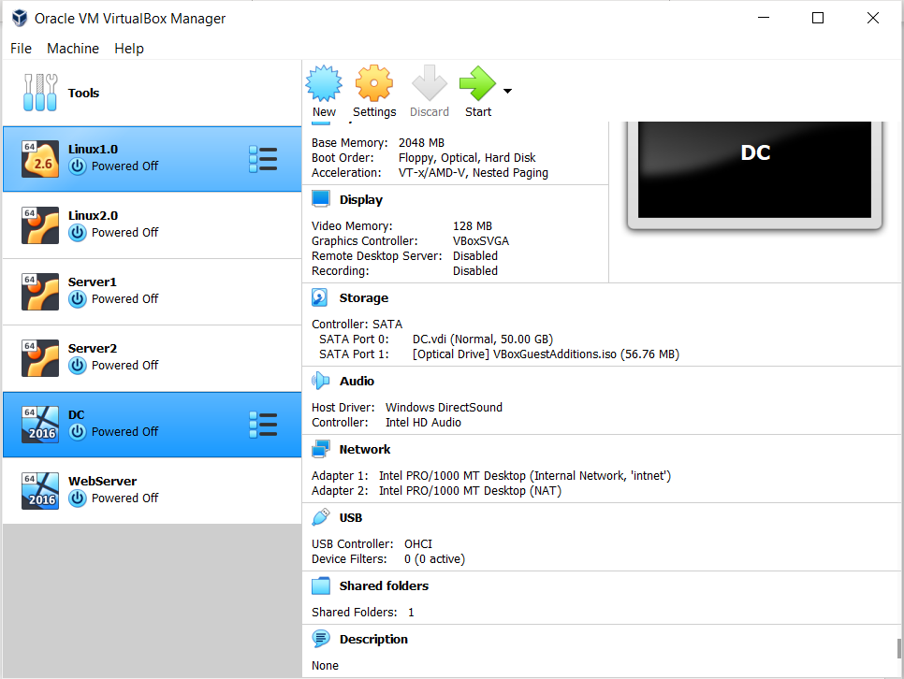

2. Configuration of DC through PowerShell.

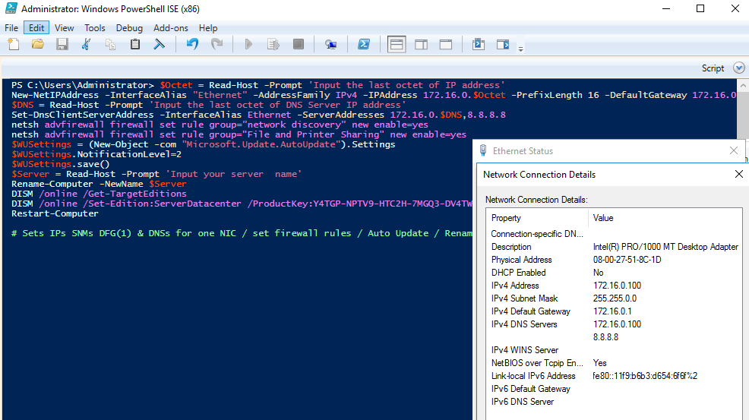

3. Configuration of DC through PowerShell to become a Domain Controller

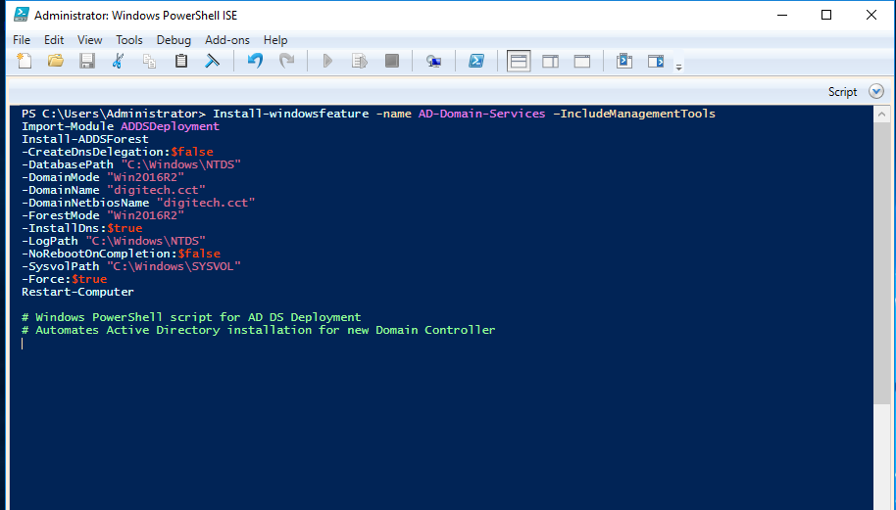

4. Verification that **www** now exists in the DigiTech Forward lookup zone.

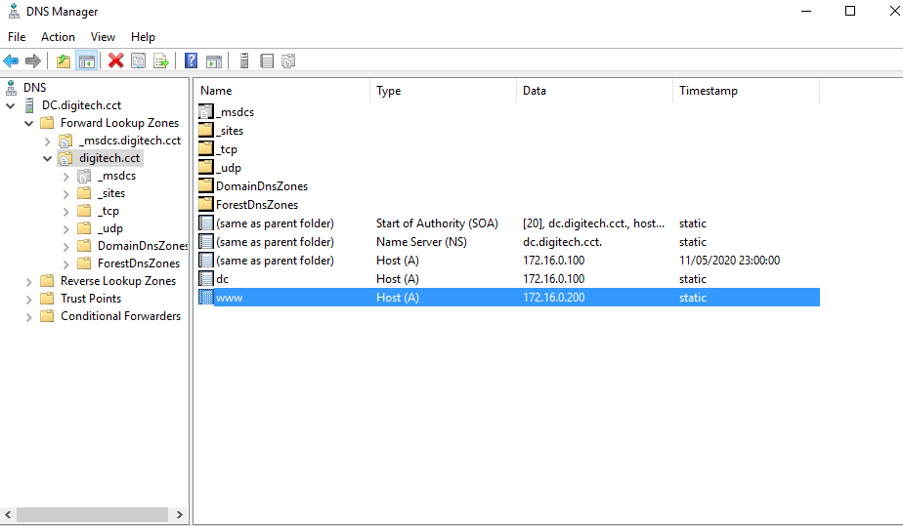

5. Configuration of WebServer through PowerShell.

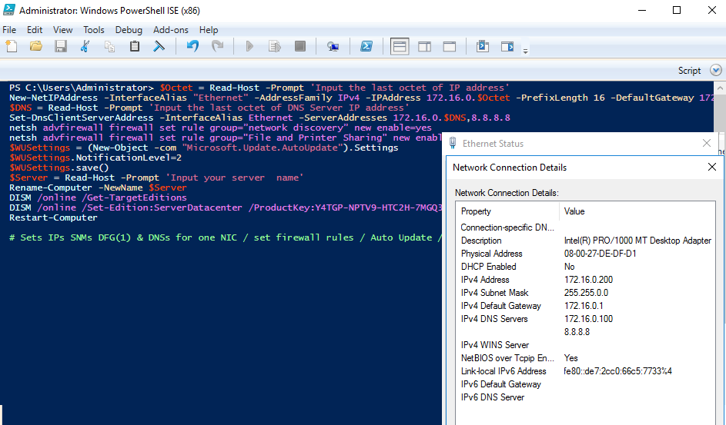

6. Prove that DC and WebServer can ping each other.

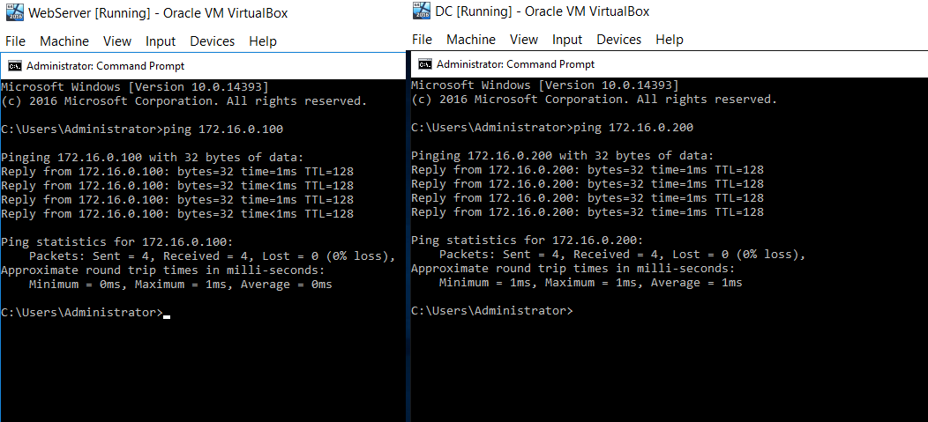

7. Prove that the WebServer was added to the Domain controller by using **script 5 (not 4 as mentioned on pdf)**.

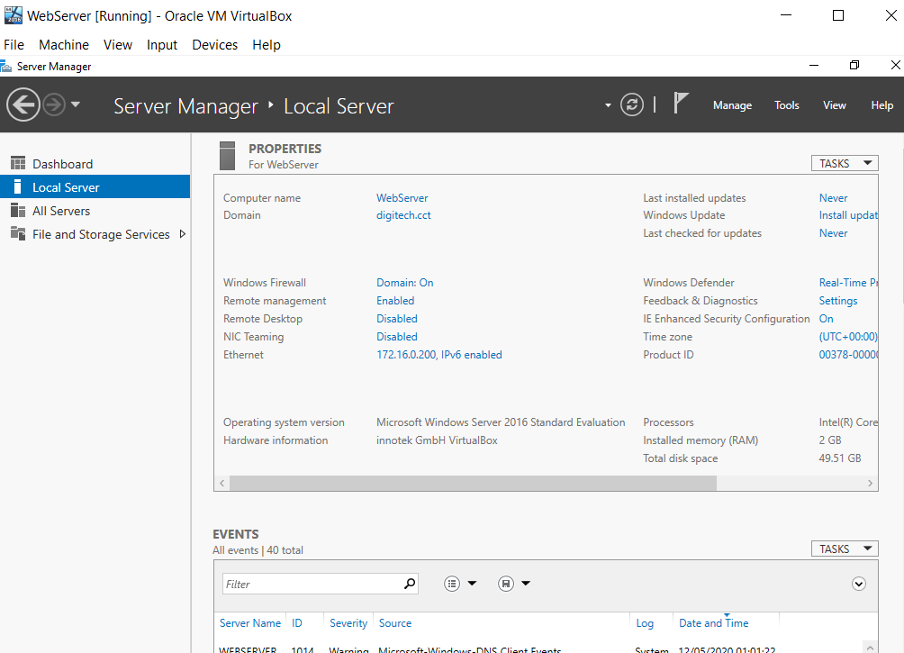

8. Prove that **WebServer** was convertedinto web server using **script4.**

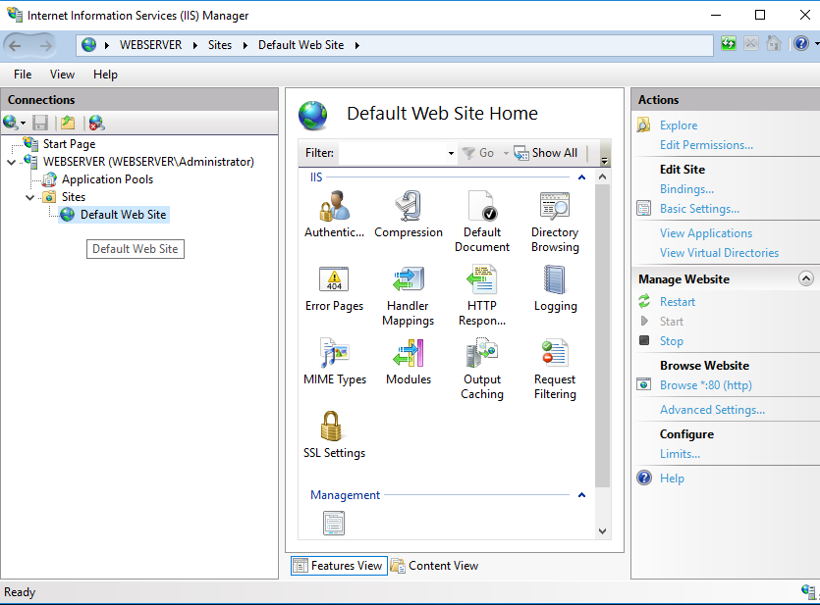

9. Prove that www.digitech.cct is working on WebServer and DC.

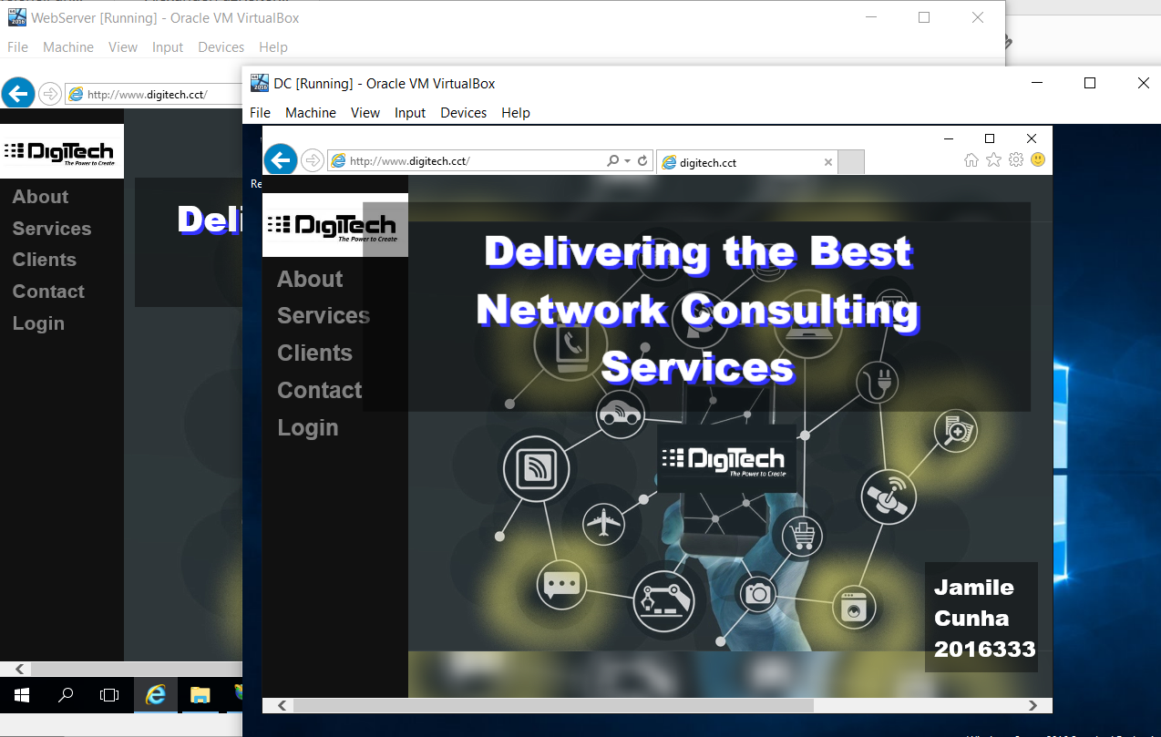

**Part 2** - Web servers and storage in the cloud

Creation of bucket and upload of Digitech website

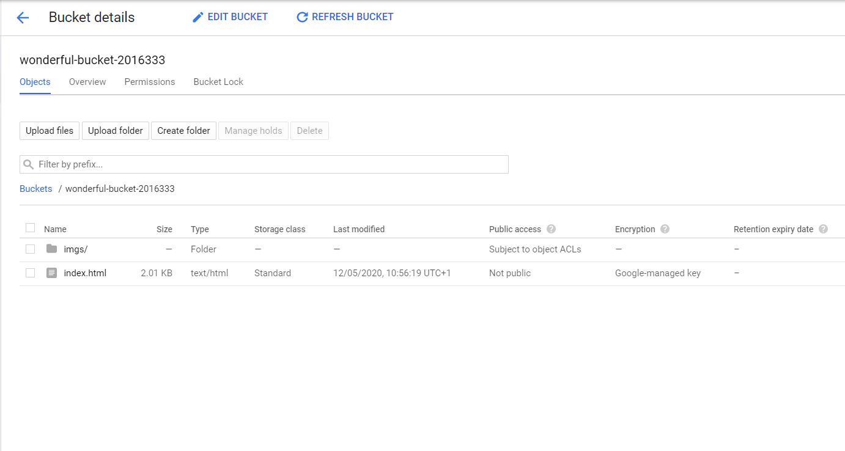

The instance linux-web was created and apache was installed.

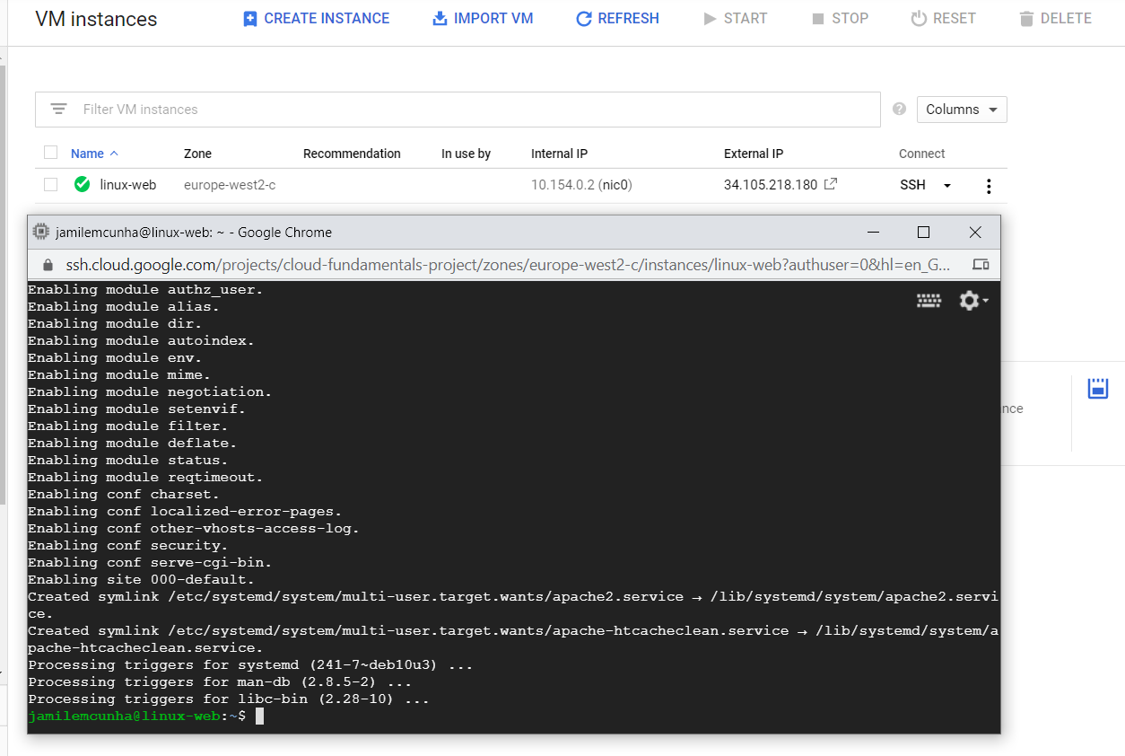

**gsutil** was used to upload files from bucket to the vm **linux-web**. Prove that the external IP address is getting my website.

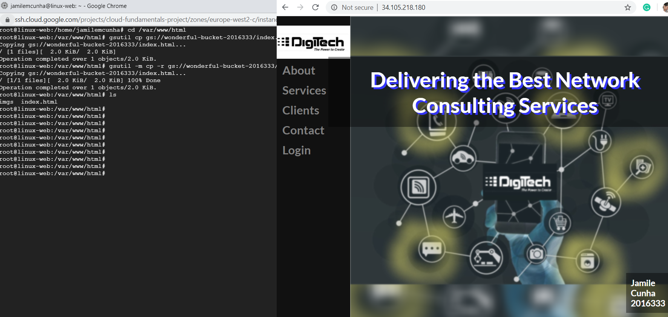

One **Instance template** was created and **startup-script.sh** was edited.

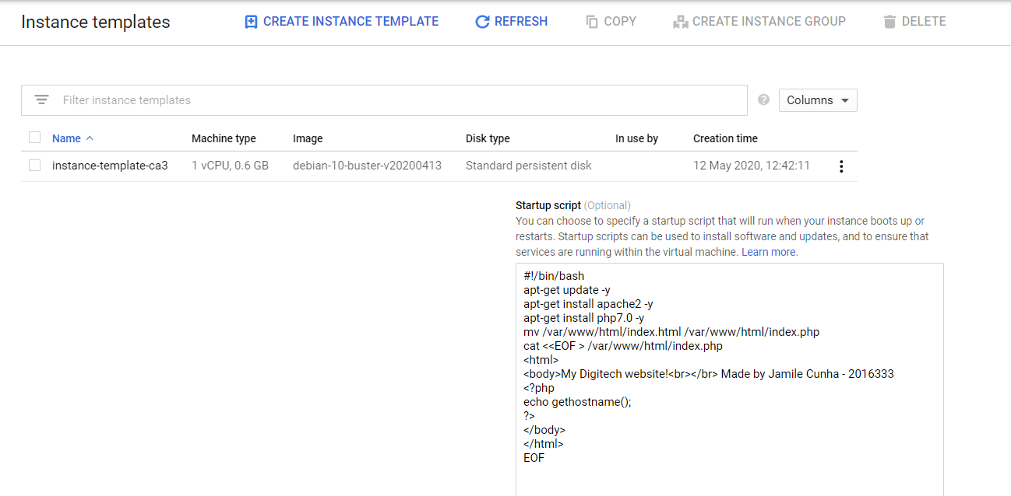

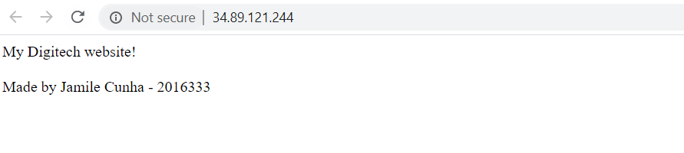

Two instance groups were created.

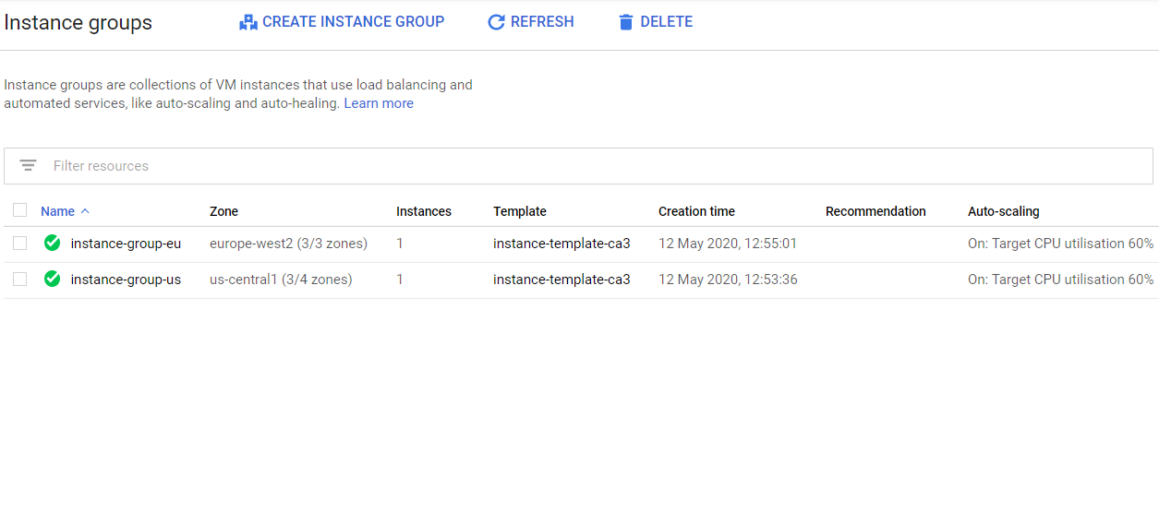

Health Check was made.

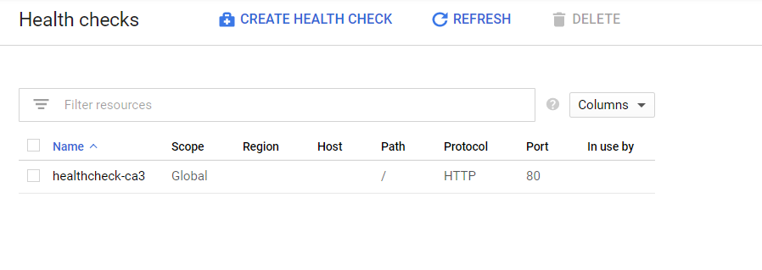

Prove that the **Autoscaler** responds to stress by scaling out to produce additional server instances

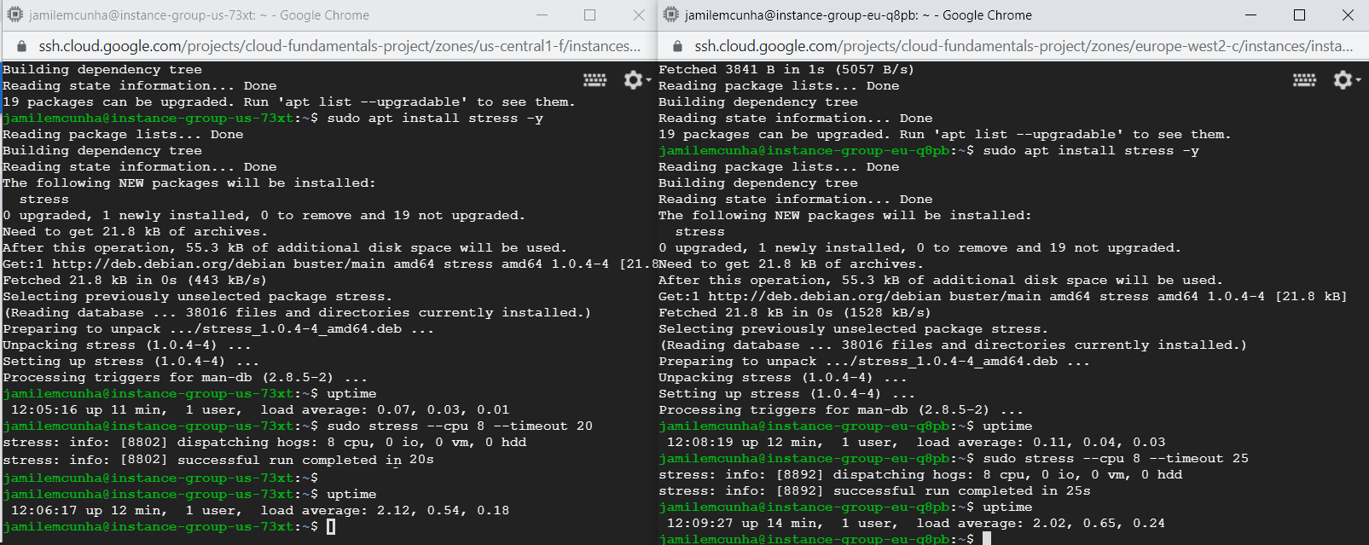

Prove that instances have been created using autoscaler after the stress testing.

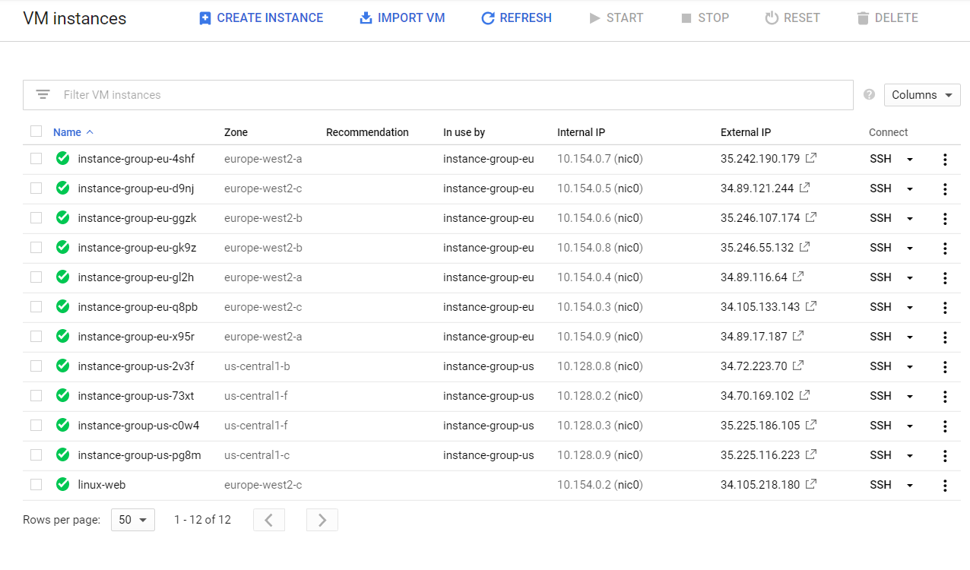

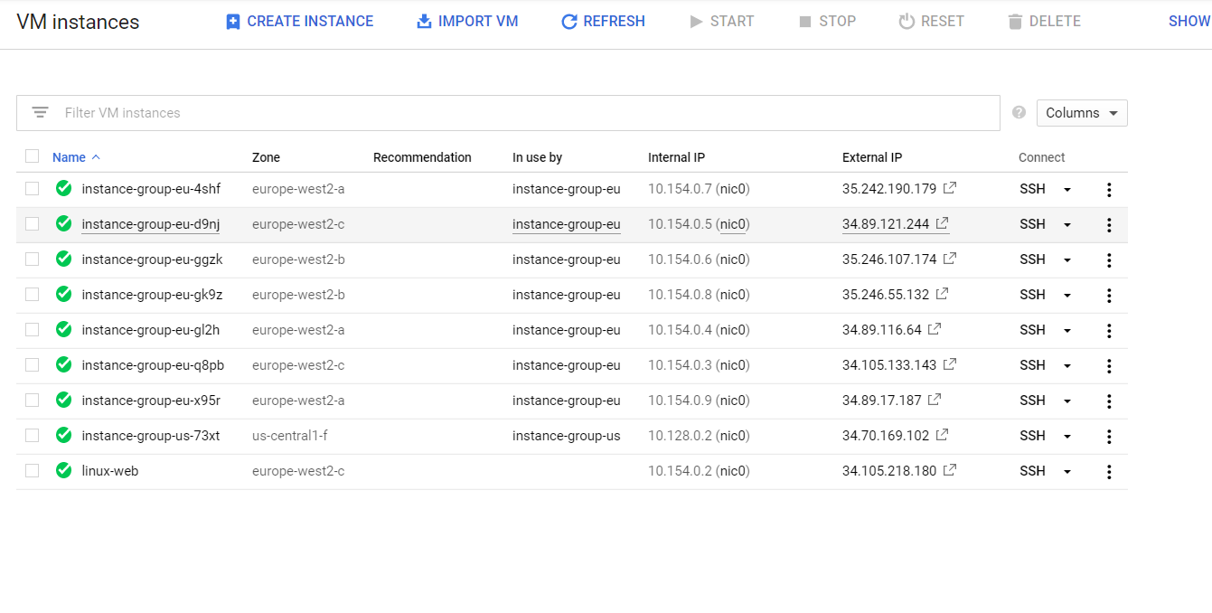

**Part 3** – Challenge Task

Modified **Startup-script.sh**

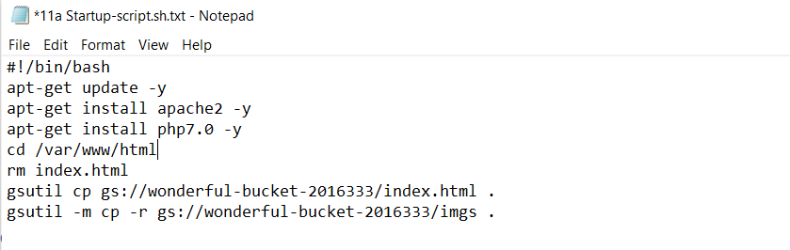

Prove that the modified script was uploaded, and everything was working as it should.



# **References**

Google Cloud. 2006. *Uploading Objects  |  Cloud Storage  |  Google Cloud*. [online] Available at: <https://cloud.google.com/storage/docs/uploading-objects> [Accessed 10 May 2020].

Google Cloud. 2006. *Downloading Objects  |  Cloud Storage  |  Google Cloud*. [online] Available at: <https://cloud.google.com/storage/docs/downloading-objects#gsutil> [Accessed 10 May 2020].